The Economic and Social Council

Social Dialogue
In Jordan

I. SOCIAL DIALOGUE IN JORDAN
Introduction
Social dialogue in Jordan is a significant component of the relationship among the different actors in society; and of the country’s political, economic and social environment. The practice of social dialogue was emphasized in 1989; the year witnessing major political reform and the reestablishment of democratization. A major milestone in the emphasis on social dialogue is represented by the establishment of the Economic and Social Council in 2009; the official platform for social dialogue. Continuously, the country is actively committed to promote social dialogue and encourage the various stakeholders in taking part in this national practice.
History
The emergence of the practice of social dialogue in Jordan can be dated back to 1989; the year witnessing major political reform in the country. The reform was initiated by the reintroduction of parliamentary elections after a suspension of about twenty two years since 1967. In pursuit of that came the emergence of political parties to Parliament; the growth in trade unions, associations and civil society institutions; and “the expansion of press freedoms and a firm commitment to pluralism and human rights”.
The democratization process during this time, significantly supported the concept of social dialogue, most notably through the drafting of the Jordanian National Charter. The Charter was drafted by a 60 member royal commission appointed by His Majesty the late King Hussein; representing all political groups in the country. The Charter “outlines the guidelines for constructive dialogue between the executive and legislative organs, as well as between decision-makers and political and intellectual elites concerning questions of authority, rights and responsibility”. It was adopted in 1991 at a national conference of 2000 leading Jordanians. “The National Charter, along with the Jordanian Constitution, provides a compass for the national debate on fundamental issues”.
Further emphasis on the importance of Social Dialogue in Jordan took place in the midst of the Arab Spring and the political unrest witnessed in the Middle East Region in 2011. Jordan was among the few countries like Tunisia and Morocco, in which social dialogue, instead of violence, was utilized to express requests for more political and social reform.
Participants
Social Dialogue is a multi-stakeholder arena in Jordan. All relevant actors in society are encouraged to participate in dialogue. Participants involved include but are not limited to, public sector representatives; associations, trade unions and employers’ organizations, such as Chambers of Commerce and Industry, from the private sector; political parties and activists; academics and field experts; and civil society organizations.

II. THE ECONOMIC AND SOCIAL COUNCIL
Introduction
The Economic and Social Council of Jordan (ESC) is a quasi- government institution linked directly to the Prime Minister. The essence of the ESC lies in the fact that it is the government’s consultative body and the country’s official platform for social dialogue.
History
The ESC was decreed on the 23rd of October 2007 and was established on the 7th of July 2009 with the objective of acting as an advisory body to the Jordanian Government on economic and social issues and policies.
With the establishment of the ESC, Jordan is one of 75 countries around the world in which a council operates to build social partnerships and provide its government with public policy recommendations; aiming to make policies fair, comprehensive and responsive to the needs of the citizens.
Structure
According to the ESC’s amended regulation for the year 2018, the ESC is headed by a board of trustees comprised of a president of the board and a maximum of 15 members.
The ESC is comprised of five groups, each consisting of nine members. The first group consists of representatives from Ministries and official institutions; the second consists of representatives of Employers; the third consists of labour representatives; the fourth group consists of representatives from civil society institutions and the fifth consists of representatives of academics and entrepreneurial youth. It is important to note, that as per the amended regulation, representation of women in the Council should not fall under 30%.
Four committees were created at the ESC. The Economic Policies committee provides policy recommendations on macroeconomic issues; such as fiscal and monetary policy. It is also responsible to address draft laws related to economic policies. The Social Policies committee provides recommendations on immediate social priorities such as dealing with social tension and basic safety nets. The committee fulfills its mandate through promoting social dialogue and conducting field visits across Jordan to engage stakeholders in their work. The labour Policies committee provides policy recommendations related to labour issues and employment in addition to promoting tripartite dialogue between labour, employers and the government. The committee also works on empowering labour institutions and building their capacities in collective bargaining as well as directing Jordan’s Labour Law towards international labour standards. The Educational Policies committee provides policy recommendations on educational issues and human resource development. The committee’s work focuses on the links between education, vocational training and labour markets.
The ESC is headed by Dr. Mustafa Hamarneh who has been in position since February 2017. The Secretary General is Mr. Mohammad Nabulsi who was among the first employees of the ESC since 2009. A team of researchers and policy coordinators work on coordinating research projects and dialogue sessions.
Work
The ESC’s work covers two interconnected scopes. Firstly, being the government’s consultative body, the ESC has the mandate to advise the Executive Authority with regards to social and economic policies. The ESC may also advise the Judiciary and the Legislative Authority upon the Prime Minister’s approval. With that aim, the ESC works on conducting research and producing written publications either upon request or at its own initiative. The ESC’s written publications include: research papers, policy papers, opinion papers and position papers.
Because the ESC works on covering a wide range of economic and social sectors and topics, to assure the quality of research output the ESC works with external experts from various specialties. Also to assure quality, it is procedure that research output is subject to a process of refereeing, whereby each paper is reviewed by at least two other experts from the field before it is published.
Moreover, papers produced by the ESC are often put forward and discussed in sessions attended by members and various stakeholders from the field at study. Participants in these sessions are encouraged to express their opinions and views and to put forward any comments or criticism they may have with regards to the paper at hand. Not only does this assure the quality of the paper, it also emphasizes the ESC’s commitment to utilize the importance of dialogue in facilitating the participation and involvement of all stakeholders in policy making.
The biggest research project undertaken by the ESC in 2018 is its “State of the Country Report”; a comprehensive report covering 36 economic and social sectors and topics. The report takes on the form of an internal audit aimed at evaluating the government’s strategic plans; in terms of what has been achieved and implemented and what has not. The report then moves on to providing recommendations on how to move forward. The first draft of each chapter in the report was presented for discussion in a series of 35 sessions. The sessions were attended by researchers, experts and specialists who participated in discussing the draft chapter. Participants provided their suggestions and recommendations which were consequently accounted for in the final report. In total, over 700 researchers, experts and specialists took part in the construction of the report.
The ESC also works on producing research papers in response to significant currently prevailing economic and social issues. For example, the ESC is currently working on producing a paper to evaluate the socioeconomic effects of the government’s latest decisions to increase the sales tax on selected items.
Other papers published by the ESC over the previous year cover topics such as: Combating Narcotics, SMEs, The Financial Situation of Public Universities, Vocational and Technical Education and Training, Public Transport, Pension Funds and Good Governance, and Climate Change.
The second scope of work undertaken by the ESC is with regards to being the country’s official platform for social dialogue. Besides utilizing discussion sessions to appraise the research output it produces, the ESC employs discussion sessions to foster and encourage positive social dialogue among different stakeholders on the most important economic and social issues, policies and decisions and on matters that concern Jordanian citizens. The ESC does so either in response to a particular request or at its own initiative.
For example, the ESC is the platform and the intermediary for the public-private dialogue concerning the telecommunications sector. The dialogue was initiated in response to the request from the three telecommunications providers in the country asking to discuss the challenges faced by the sector with the Ministry of Information and Communications Technology; such as the tax structure imposed on the sector.
Another example of the ESC’s work with regards to emphasizing social dialogue is through holding a series of discussion sessions on a number of proposed draft law amendments. The ESC gathered the relevant stakeholders for each draft law; aiming to gather consensus on comments, suggestions and recommendations to be put forward before the passing of these laws to the cabinet. Among the laws discussed was the Crimes Prevention Law, the Amended Cyber Crimes Law, the Draft Law for Personal Data Protection and the Buildings’ Regulation in Municipalities and in Amman.
Also, with the aim of activating social dialogue, the ESC hosted two important conferences over the previous year. Both conferences were attended by local and international stakeholders; from the public sector, the private sector, the civil society and the fields of research and academia. The first was with regards to the Impacts of the Syrian Refugee Influx on the Jordanian Economy; specifically with regards to Housing, Education and Employment. The conference was held in partnership with the Economic Research Forum and the Department of Statistics. The conference tackled the subject matter through presenting a number of research and policy papers based on the second round of the Jordan Labour Market Panel Survey. The second conference, The SMEs Conference: Enhancing SMEs Socio-Economic Performance…Towards a New Economic Model, was held in partnership with the Jordan Chamber of Industry. The conference tackled the importance of enhancing the performance of SMEs in Jordan as a tool for increasing growth and employment opportunities.
More on the ESC’s work in promoting social dialogue is given by its currently ongoing work, in cooperation with the Ministry of Political and Parliamentary Affairs, in creating and activating the framework of the national dialogue on the decentralization process in Jordan. The aim of these sessions will be to reach consensus and to gather recommendations to formulate a comprehensive vision for a national strategy for the decentralization process in Jordan. This is expected to form the basis for strengthening local administration, citizens’ participation in the decision making process, and in emphasizing democracy. Till date the ESC has held 7 sessions of this series. These sessions were attended by various stakeholders such as; experts and academics of the field, the country’s political parties, the Legal Committee from the House of Representatives, and the Governors from the country’s twelve governorates.
In this context, and on many occasions, dialogue has led to the formulation of a complete and balanced set of policies; placing the individual at the core of the policy making process and integrating the individual’s needs and opinions in the process of development. The concept of allowing the participation of private sector, trade unions, employers and civil society institutions in the work of the government has proven to be effective in bridging ideas and opinions. Also, the broadening of the decision-making scope allows for increasing the credibility of policies and decisions that affect the interests and lives of different social groups.

III. THE FUTURE OF THE SOCIAL DIALOGUE IN THE COUNTRY
Continuing its efforts to promote and institutionalize social dialogue in Jordan, the ESC has proposed to the Prime Minister the establishment of a Public-Private Dialogue Unit at the ESC. The main purpose of this unit will be to allow individuals and organizations from the private sector and the civil society, who are not part of the ESC’s groups to participate in social dialogue and to utilize the ESC as a platform through which they can tackle issues that concern them.
The unit should consist of several sub sectoral committees in order to cover the various sectors of the economy. The ESC is still working on the proposed structure of the unit in collaboration with the Chambers of Industry and Commerce in addition to the various stakeholders who are keen to enhance social dialogue in Jordan.
One of the main goals of this unit will be to establish the social dialogue between the different sub sectors in the economy, through their representatives; to draft a consultation law. The law would be such that it would make it binding for the government to consult with the ESC and different stakeholders, on matters with regards to social and economic policies and decisions.
Other prospective plans that will contribute to the efforts aimed at enhancing social dialogue in Jordan, is concerning the law governing political parties. The Ministry of Political and Parliamentary Affairs is planning to launch a dialogue series to discuss the law and its possible reform.
The significance of social dialogue and the emphasis on its use has been increasing; specifically in response to the country’s economic challenges and the region’s political unrest. Future goals and efforts are in place to further and continuously increase and strengthen the application of social dialogue in Jordan.

The ESC’s Work- Selected Photos
1) State of the Country Report
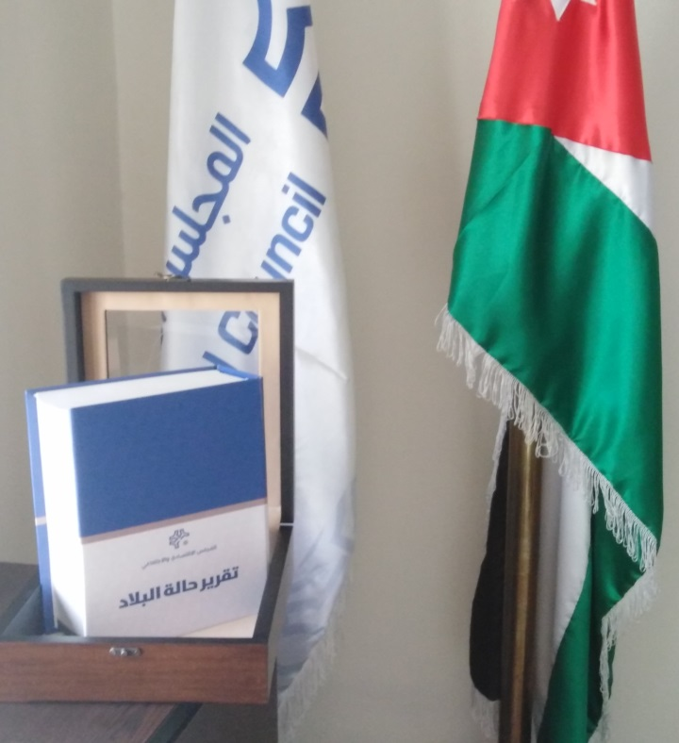

2) State of the Country Report- Discussions Sessions
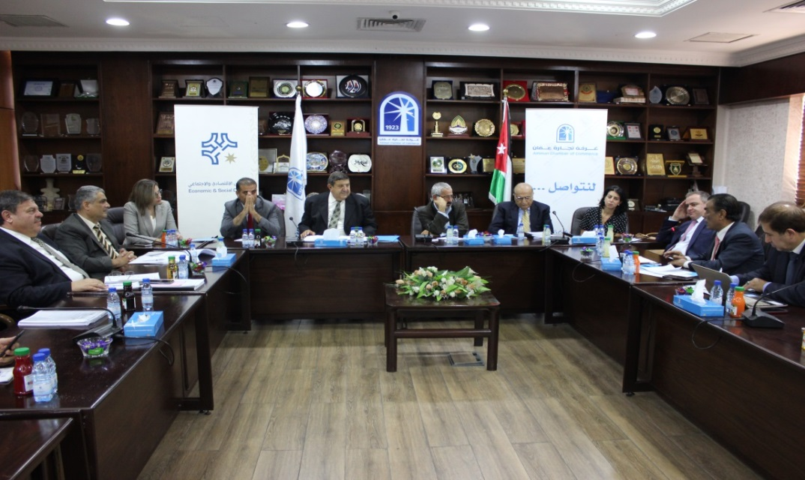

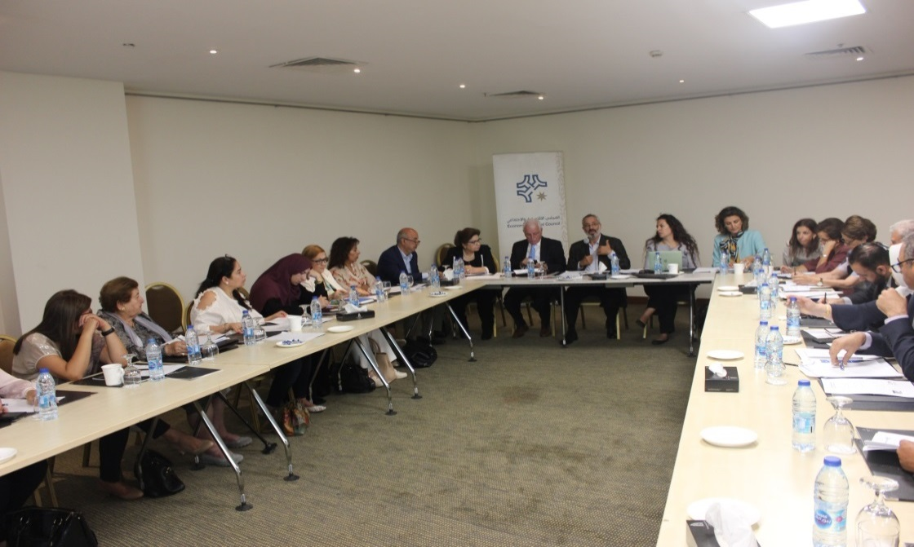

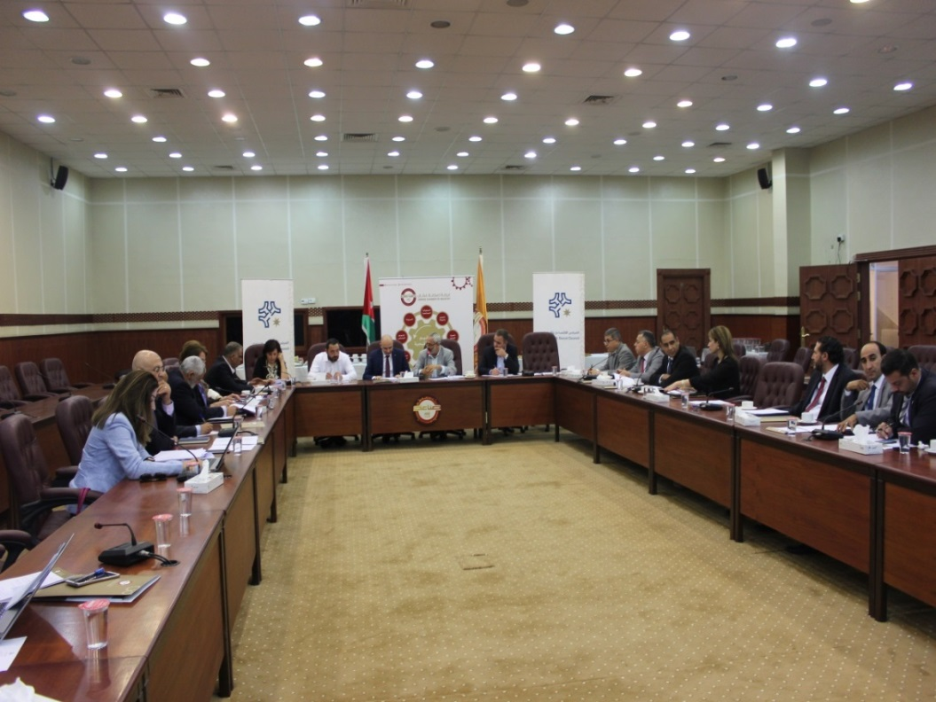

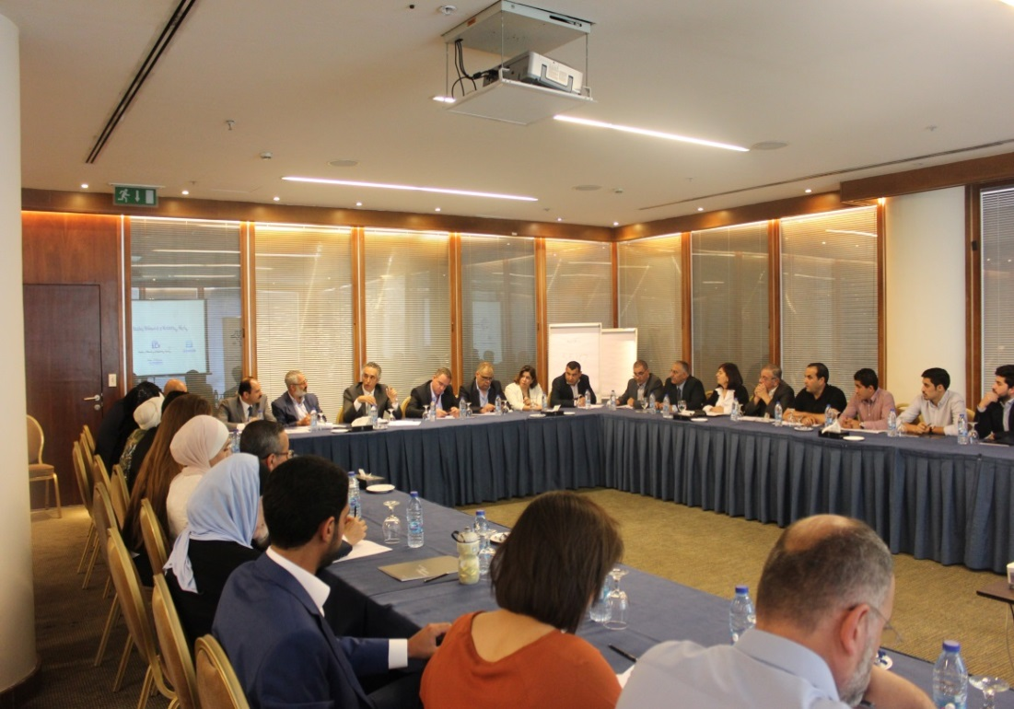

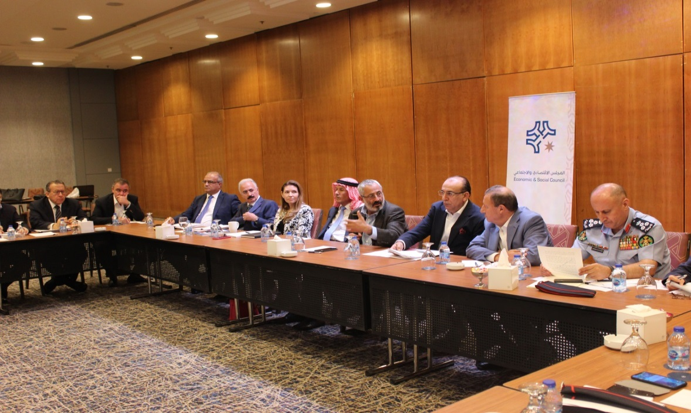

3) Telecommunications Sector Public-Private Dialogue
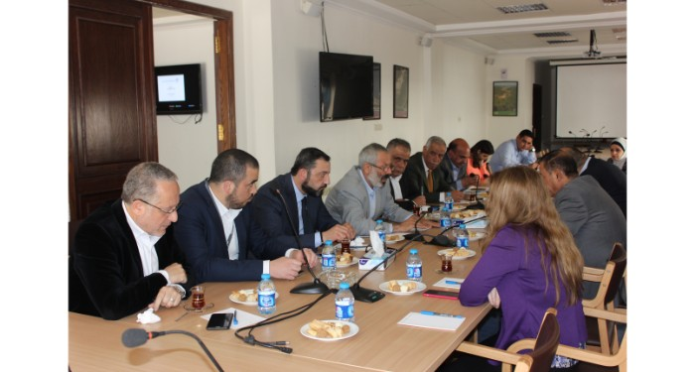

4) Discussion Sessions on a Number of Proposed Draft Law Amendments
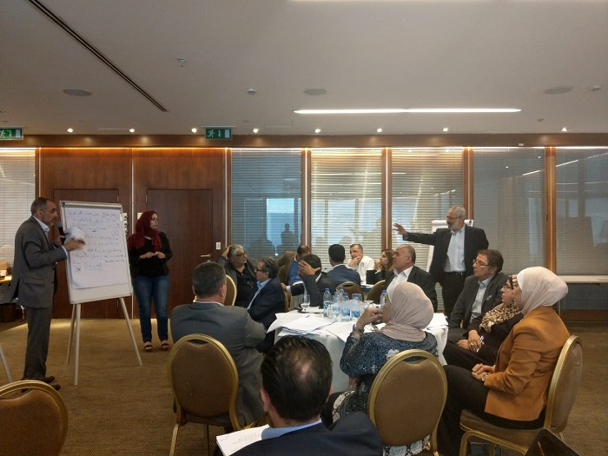

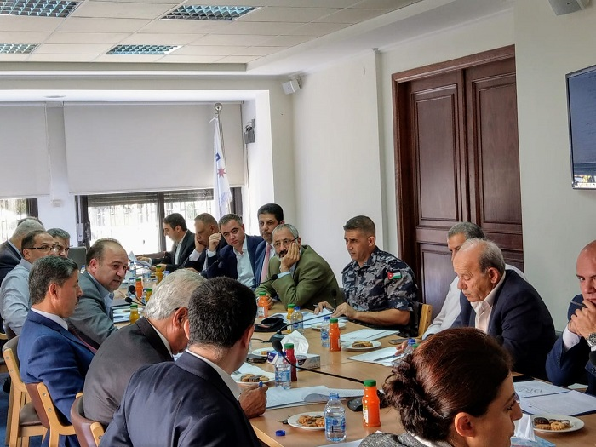

5) Conferences
a) Employment, Education and Housing in Jordan: The Impacts of the Syrian Refugee Influx
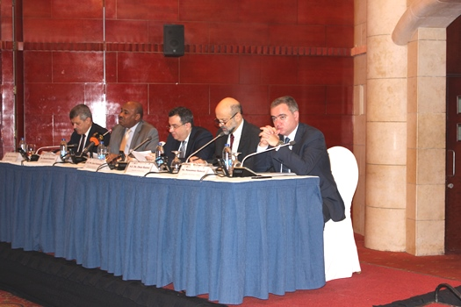
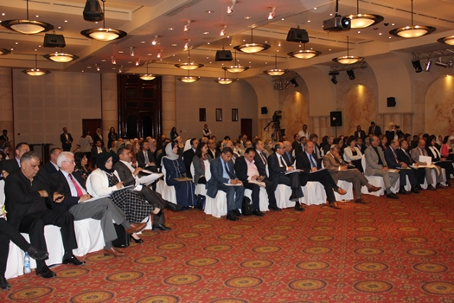
b) The SMEs Conference: Enhancing SMEs Socio-Economic Performance…Towards a New Economic Model
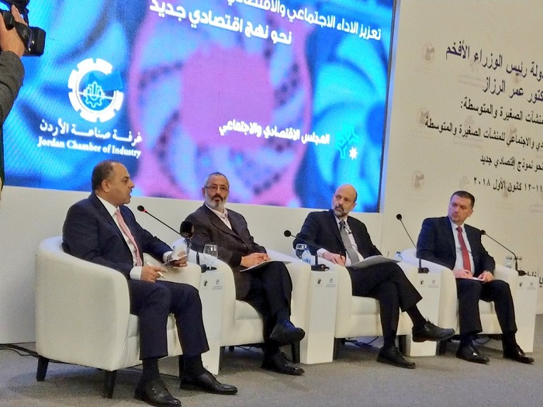

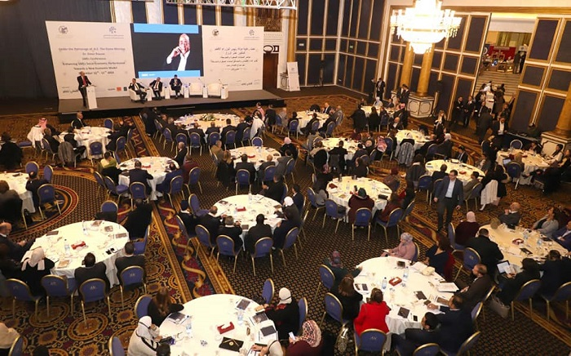

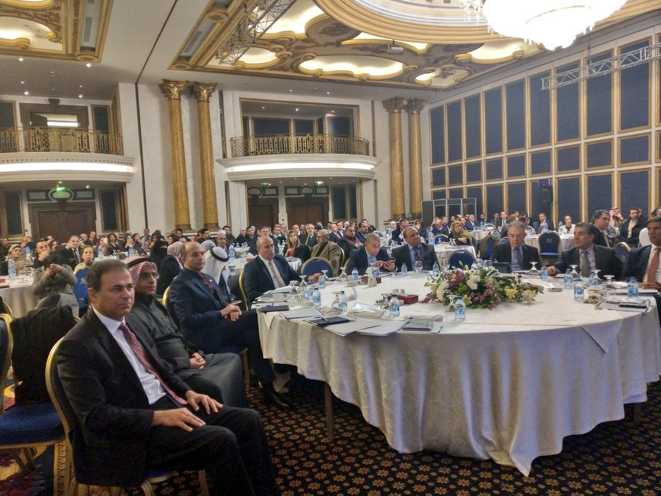

http://www.kinghussein.gov.jo/his_periods8.html
http://www.kinghussein.gov.jo/charter-national.html

